How  to delete a repository?

1. **click that repository you want to delete, then  you see a button “setting” on the right,  click it.**

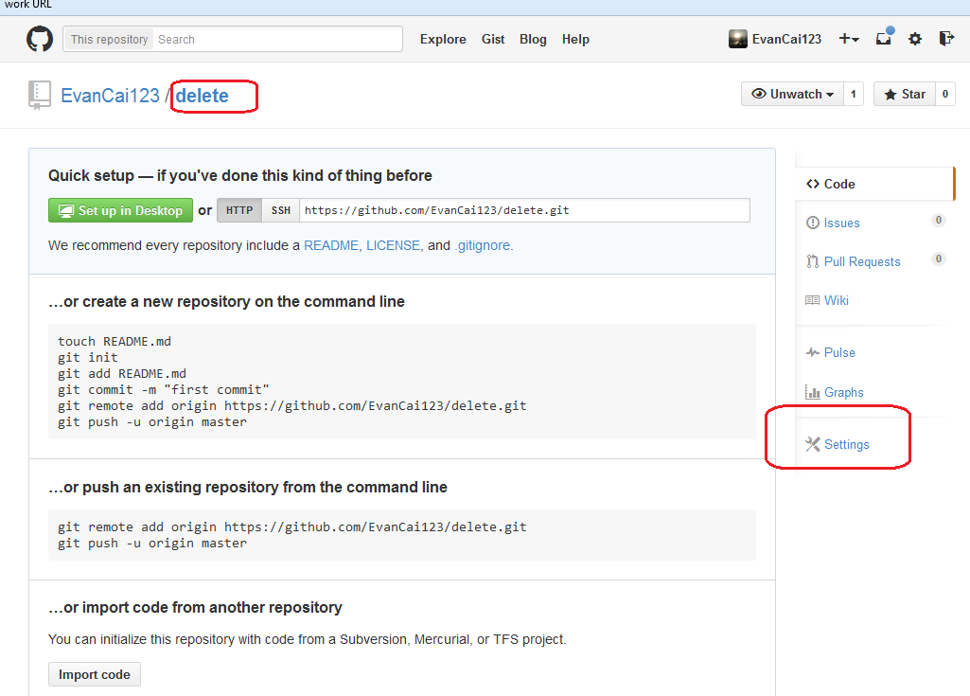

**2.** **At the bottom of the page,we will found the following figure,click “Delete this repository”.**

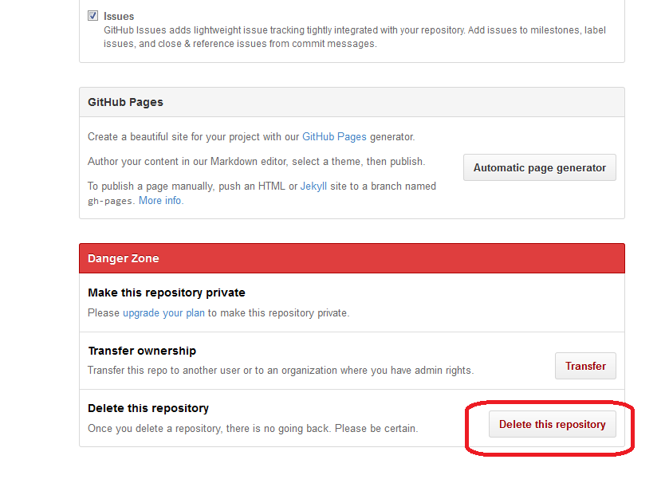

**3.  Input this repository name and click the button”I understand the……..”.**

**OK. You have deleted this repository successfully.**

